Infrared scanning code operation document

Trigger mode
Users can select trigger mode in settings and scanning interface of hardware app;
In the hardware app code scanning interface, you can set whether to check the continuous code scanning mode and whether to make the volume key trigger the code scanning mode to take effect.
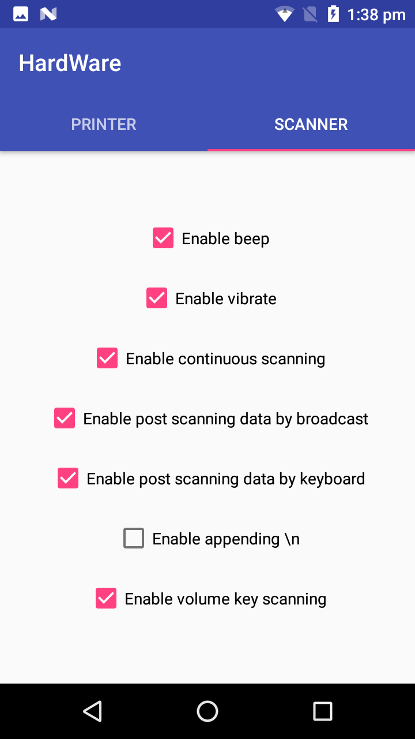
Set whether to trigger code scanning by pressing volume key + or volume key - in settings.
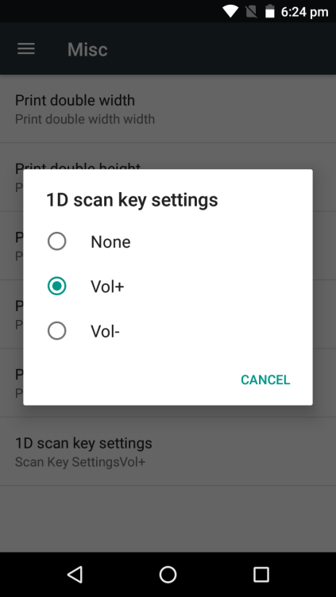

2、Prompt mode
Users can set the prompt mode in the code scanning interface of the hardware app
The buzzer prompt is checked by default


3、Input mode
The user can set the input mode of scanning results in the scanning interface of the hardware app;
By default, the keyboard mode is checked to input the code scanning data, and the auto carriage return mode is not checked by default (\ n);

By default, the broadcast mode is checked and the code scanning data is input.
Broadcast input: the code scanning result will be sent as broadcast, and the user can monitor the broadcast to obtain the code scanning result.
Keyboard input: the code scanning result will be simulated as a key event and will be automatically output to the focus box text. The user can obtain the code scanning result by obtaining the content of the focus box or monitoring the key event;
